**Physics 4**

The area of metallic bar is 1x1cm.Its length is 50cm.A force of 10000N stretches it by 0.25cm. Find stress.

**Explanation:**

We are given the area the length of a metallic bar. A force is applied on the bar and the length of bar increases. The program calculates stress and strain on the metallic bar by using stress and strain formulas, as output.

**INPUT:**

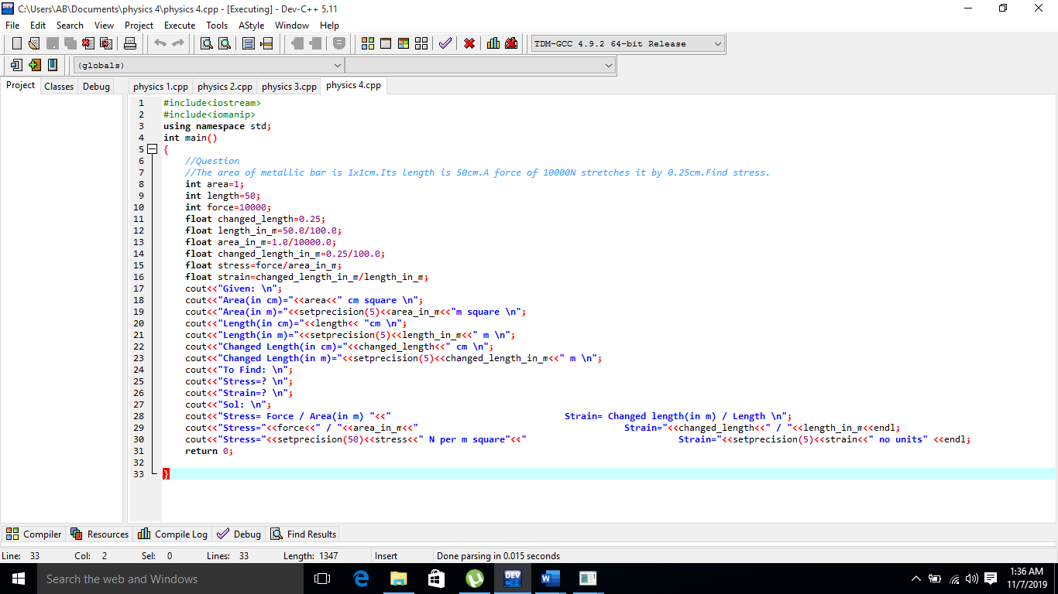

**OUTPUT:**

